Date-24-Nov-2018

Internal Quality Audit Report- Workflow

Internal auditor audits the site/department against some pre-determined standard requirements/best practices. Then auditor prepares an ‘Internal Quality Audit Report’ and classifies report descriptions under any of the below three heads

- Information
- Observation
- Non-conformance- There can be multiple Non Conformances in one Internal Quality Audit Report

For the each Nonconformance in Internal Quality Audit Report , auditor prepares a detailed report as ‘Non-Conformity Report’.

Broadly Non- Conformity Report contains
- Information about Audited Site/Department, Audit date, Name of Auditee, Name of Auditor
- Process/Reference number, Clause number, NCR No.
- Type of Non Conformity Found (Minor/Major)
- Description of Non Conformance (Under sub heads of Problem, Evidence, Impact)
- Standard Requirement
- Signature of Auditee(agreed about nonconformance ) and Auditor
- Date by which correction and corrective actions are to be completed.
- Root cause for non-conformance
- Corrections
- Corrective Action Auditee has to submit these
- Follow up details Auditor has to fill this
- Auditor and Management Representative on Close out

Auditor has to create as many separate ‘Non-Conformity Report’ as found during Internal Quality Audit.

Process Flow Chart:
Start

Create Internal quality Audit Report

Non Confirmance-3
Non Conformance-2
Non Conformance-1
Observation
Information

Non Conformance Report-1
Non Conformance Report-2

Non Conformance Report-3

End
End

Proposal of Root Cause, Correction and corrective action by Auditee

Follow up by Auditor

Acceptance of NCR BY Auditee

Closure by Management Representative

End

Table Structure – Internal Quality Audit Report(Master/Parent Table) – Form1

Sr No | Column | Values
0 | Internal Audit Report No. | Augenerated Number
1 | Site/Department | String
2 | Auditee Name | Employee Code
3 | Audit Date | Date
4 | Auditor Name | Employee Code
0.1 | Description | 3 lines
0.2 | Auditor Remarks | Information/Observation/NCR
0.3 | NCR No. | Numeric zoom from form2

Table Structure - Non-Conformity Report’(Child Table)- Form2
Sr No | Column | Values
0 | Internal Audit Report No. | Zoom from form 1
7 | NCR Number | Autogeneratd from 1 for each Internal Audit Report No.
5 | Process/Reference Number | String
6 | Clause Number | String
8 | Non Conformity Type | Major/Minor
9 | Problem | 3 lines
10 | Evidence | 3 lines
11 | Impact | 3 lines
12 | Standard Requirement | 3 lines
13 | Correction Date | Date
14 | NCR Raised by(Auditee) | Employee Code
15 | NCR Agreed by(Auditor) | Employee Code
16 | Root Cause | 3 lines
17 | Correction | 3 lines
18 | Corrective Action | 3 lines
19 | Follow Up Details | 3 lines
21 | Management Representative Name | Employee Code
 | Status | - NCR Created by Auditor  - NCR Forwarded to Auditee  - NCR Accepted by Auditee  - NCR Replied by Auditee  - NCR Followup by Auditor  - NCR Closed by Management Representative

Web Page 1- Create Internal Quality Audit Report

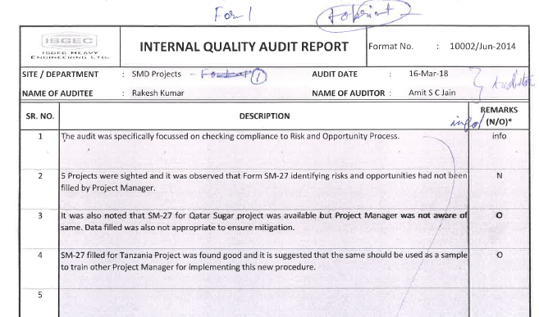

Web Page -2- Create NCR
  - NCR Created by Auditor
  - NCR Forwarded to Auditee
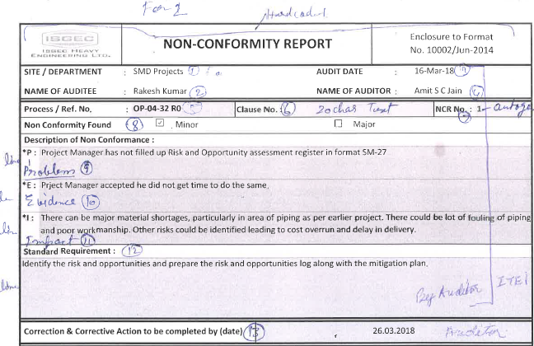

Web Page-3 – Accept NCR
  - NCR Accepted by Auditee

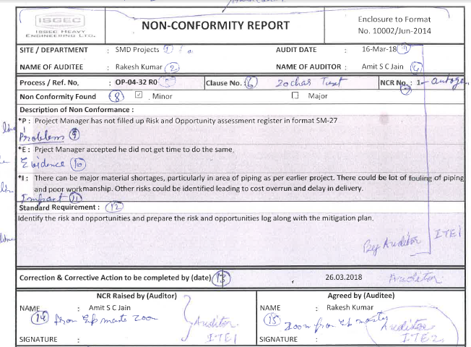

Web Page-4 Reply NCR
  - NCR Replied by Auditee
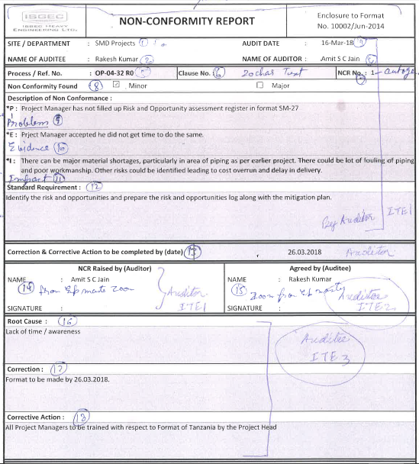

Web Page-5 Followup NCR
NCR Followup by Auditor
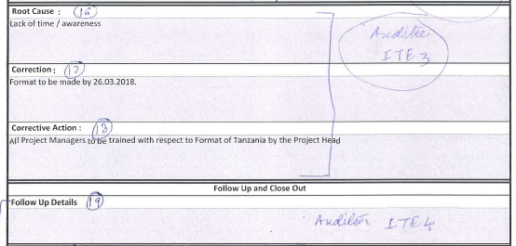

Web Page-6 Close NCR
NCR Closed by Management Representative

